# Daily Notes (Dose) of ASL Research

Junwoo Hwang

This document aims to document/keep track of what I learned/did throughout the research period (Nov 21, 2022 ~ Mar 8, 2023).

This can include things not directly related to the research itself and is meant to be more of a diary. So make things fun!

* [Timetable sheet](https://docs.google.com/spreadsheets/d/1gRUlbYvnPrwVNK0voVHIvJMp7Np7mySwbJ8ahxjhzzI/edit#gid=1680505909)
* Note: Daily notes are kept in Heading 3 font. Weekly will be in Heading 2.

## Week 12 - Feb 6, 2023 ~ Feb 12, 2023: Chamonix

### Feb 12, 2023 - Week of Chamonix has passed by and now..?

## Week 11 - Jan 30, 2023 ~ Feb 5, 2023

GOALS

1. Formulate curve that *ideally approaches unicyclic curve, as V_path increases
2. Show in Vector-Field how the new formulation *makes sense

### Feb 4, 2023 - Hello on Saturday at SPH

* 1718: Nice talk with Adriel and Zacharie during lunch, quite fun to have these meetings!
  + But I realized I shouldn’t be so harsh on myself. It’s ok to fail, and not do much as I *wish, it’s part of the process as well
  + But Adriel also said for his past semester project, he wished he had done more
  + I have 1 month. So I should give all I got 🤯

### Feb 2, 2023 - Oh stuck in Thursday

* 1448: At Irchel. Crazy how fast the day goes by! It’s almost friday as well 🤯. Why do I procrastinate so much? + Do I wanna go to Zentrum 🤔.
* 1509: Will leave Irchel. Can’t focus much!!!
* 1623: After kreisbuero visit. Alles klar! Glad I ran to it 😂
* 1645: With ‘Sundays’ music, focusing, once again 🔞!
* 1914: Back from Peers n Cheers. Well, I realized I’m sorta *depressed, not excited about startup stories I was hearing and all. Hmmm.
* 2436: Bouldering was nice. But after kebab I was watching youtube, for ~1.5hr.

### Feb 1, 2023 - Wednesday focusin

* 1144: At SPH, hum not so hungry so will at 1pm or sth. Velocity Formulation!!
  + Also, glad that stipend got through 🎉
* 1303: Oops haven’t been doing much. But can visit Auterion!
* 1555: Back in SPH, with all the Autopilot stuff. BUT! Need to focus on thesis first. I only have 1hr, and I need to prioritize.
* 1636: Been back for a bit. Marco is doing FPV drones, cool! But now I have 24 mins lol
* 1654: Ok didn’t do anything (browsing skis: [Ski lessons - 2023](https://docs.google.com/document/u/0/d/1avhy-xwG3QEXFg8zdEIwNHDuwFWWD1HYGGHjFlErIOE/edit), and discord. Hmm.)
  + But some things are needed to be done
* 2031: Ok after Jinger meeting and [KU - 수강희망과목 - 2023 1학기](https://docs.google.com/document/u/0/d/1R6RLusZ_XY2xYmS8QQ2GVnXRR7JhKFkr9C8C_49c6Vg/edit) (now I know what to do tho!), going back home lol 🤷

### Jan 31, 2023 - Tuesday chillin

* 1417: Learning Scipy. Had some Dronecode stuff + Camera rental done this morning + Jinger contact, etc. Nice to be productive!
* 1602: First Accel Limt Curve formulation & visualization done. Quite interesting, but still ‘2D trajectory’ would be interesting to observe 🤔
* 1723: Back from refreshing shopping and Laura treffen. It’s better to take breaks!! And maybe I can just build the variometer tonight.
* 1855: Tryna wind down with

### Jan 30, 2023 - Wow, it’s 11th week!! 🤯

* 1058: Making some good progress! Now just defining minimum track error boundary to achieve path speed. Quite interesting to think about this.
* I have been thinking that it is a bit of waste of time doing all of these documents, but I think having these nomenclature set properly helps in terms of longevity of equations & also practicing LaTeX is helpful!
* 1213: Kinda done with the report. But this is such a limited formulation on a straight path with just these ‘relaxed’ curves 🤦
* 1307: At lab now. Creating presentation!!
* **Learnings after the meeting:**
  + I didn’t have ‘results’ to discuss about (only formulation & *theoretical curves)
  + I haven’t done actual analysis on what happens at extremes
    - Wasn’t convenient enough to do a discussion
  + I don’t have to consider vehicle body orientation for acceleration constraints, it is simply not necessary.
* 1623: Talked with Eugenio! Making progress on Podcast side, super cool to talk about it!

## Week 10 - Jan 23, 2023 ~ Jan 29, 2023

GOALS

1. **Formulate acceleration limited velocity curve**
2. Include Wind into guidance formulation
3. Include Wind dynamics into Simulation
4. Benchmark against NPFG in Simulation
5. Implement in PX4 / SITL

### Jan 29, 2023 - Sunday squeeze

* 1736 : Train from Lugano to Zurich. Will formulate:
  + E_min_approach, resulting e_min_path, etc.

### Jan 27, 2023 - Friday, focus

* 1613: After 2+ hr of Podcast stuff (contact guests) & side-track of a bit of paraglider research, staring thesis now. At top floor (quite loud?)
* 1817: LaTeX math formulation focus. Coming together somehow!
  + 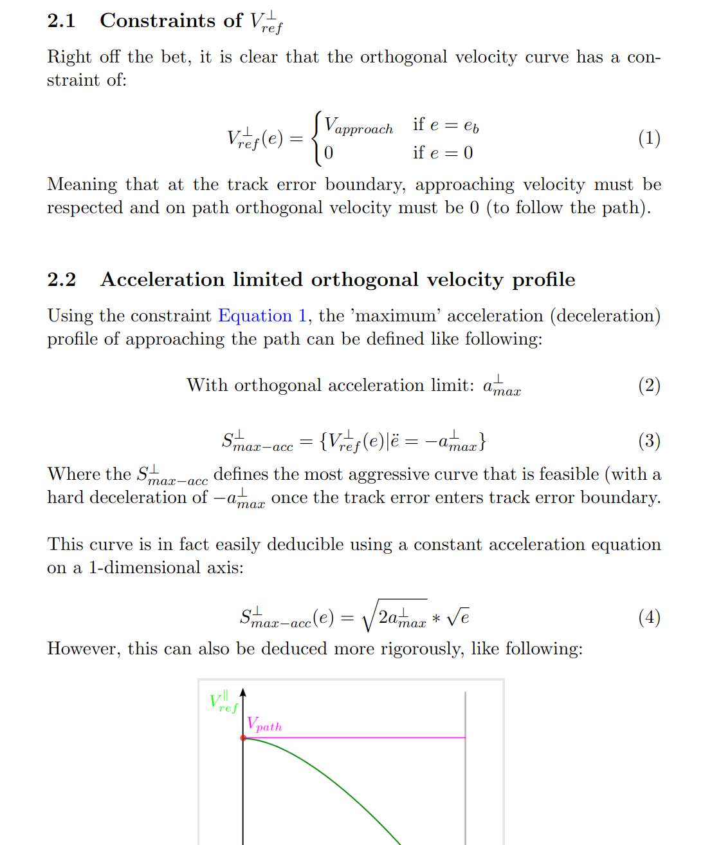

### Jan 26, 2023 - Thursday, healing from Back & focusing

Decided to stay home, after some back pain from yesterday. Goal (since Weekend is off with Laura) is to come up with genuine impactable material I can present next Monday.

* 1118: Having a meeting with Adrna & David, in Kitchen with Sesame Ramen lol
* 1646: Snif, spent the whole day watching Youtube and shit. 😞

### Jan 24, 2023 - Hopeful Tuesday

* 0903: Wow it’s been quite some time since I actually used this diary. That means I have been *slacking off. Today, my **GOALS**:
  + ~~Do a Survey on~~ **~~Acceleration~~** ~~(or Jerk) limited Vector Field based Path Following methods, and formulate their approach (general idea), in~~ [~~📜JunwooHwang_literature_survey~~](https://docs.google.com/document/u/0/d/1AOX7G4nqJ5OgIQjxfj3MbewlthpJPY_VLqvySk_M2rM/edit)
  + Come up with Mathematical representation & curve that can formulate exact acc & vel norms, in [13_AccelerationLimitedVelocityCurves](https://docs.google.com/document/u/0/d/1YKHEk2Yzxw0cizCqZqqgaWfAdxq7hHVSo3-UG_whOpE/edit)
* <https://betterexplained.com/articles/divergence/#:~:text=The%20symbol%20for%20divergence%20is,gives%20the%20divergence%20formula%20above>.
* 1345: After meeting lots of people. Back in SPH!
  + Tim: MSc, Robotics, South Africa and into Visual Odometry & UAVs (interested in MIT Thesis program)
  + Matteo: From italy, likes climbing. 22 years old!
  + Konstantin: Got contacts from israeli company (Air) to develop software for eVTOL, and now having 2 part time job (Google & Air)
    - Moved around 2018 to Zurich, because of the unexpected offer.
    - Now developing the industrial grade FC with ESD protection
    - iNAV has too much feature creep, so parted ways (wanted to keep it minimal and simple interface for the user)
* 1510: Was disturbed by EPFL Rocket Team stuff and etc. Closing gmail now, and focusing on literature survey!
* 1653: Oki it is damn hard to find actually relevant literature on accel limit. So will continue with mathematical formulation part!
* Incredible: <https://castel.dev/post/lecture-notes-1/>

## Week 9 - Jan 16, 2023 ~ Jan 22, 2023

### Jan 20, 2023 - After a nice flight day, Hoengg

* 1810: Finally came over the temptation of watching Youtube and pushed a new commit on setting track keeping speed for the chart

### Jan 18, 2023 - Oops Wednesday already

TODO

1. ~~Overleaf LaTeX Week 8 report :~~ [~~done~~](https://www.overleaf.com/project/63c7ca5f4fb2174d1bcce84a)~~! - Jan 20, 2023~~

* 1113: Now was drafting the [DIY Variometer](https://docs.google.com/document/u/0/d/1_4KdzGJ7ttVbWdHd7IesnUljLk1GrvVha69i4KQTS88/edit), and yesterday was full of tinkering idea for the [Paragliding Database Website](https://docs.google.com/document/u/0/d/1Cv6sRs3-_zMA1gisFZJstALVDBrC0wpHHKWBbkM2j70/edit). My procrastination level is skyrocketing!
  + I need to send in the weekly report, and get to Curve formulation!!!!
* 1310: Was doing [Paragliding - 2022 ~ 2023 plan](https://docs.google.com/document/u/0/d/1FGNUayxOyiB491gaqV_Q1FOFR6lVIoq2NJ1sxo1gnqQ/edit) and IPPI card stuff, man I am really… I will not do anything related to this today anymore. But it was ‘helpful’ (also stalking though..)
* 1315: Will complete weekly report & go to lunch before 1335 (20 min)
* 1530: Tryna do the nomenclature & inkscape diagram right, installing Tex and TexText plugin
  + <https://textext.github.io/textext/install/linux.html>
  + <https://linuxconfig.org/how-to-install-latex-on-ubuntu-22-04-jammy-jellyfish-linux>
  + Could be perfectionism, but I will use this in the future too for thesis so 🤷
* 1611: Some progress!
  + 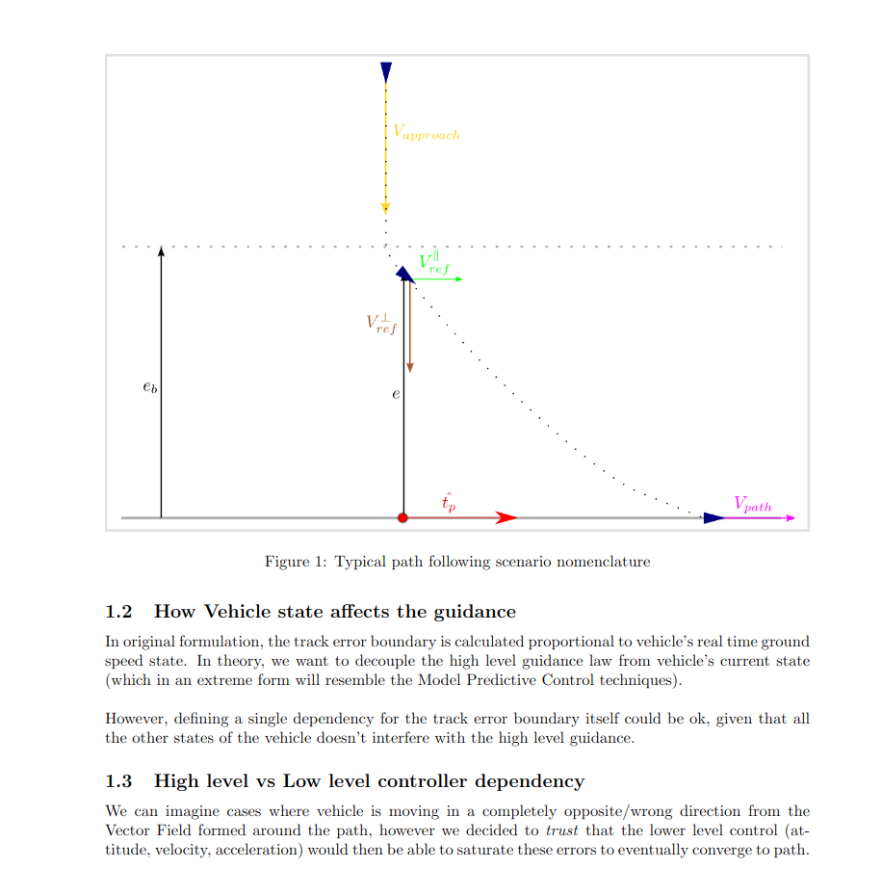
* 1645: Autoref and styling is better, figures take time, too!
* 2134: Home. Video making workshop and all, seems like my whole day has been spent on most stuff not related to thesis. I feel bad. But also, I should remember that I should focus on ‘one thing at a time’, and if I spent time doing X, I shouldn’t feel ashamed of it.

## Week 8 - Jan 9, 2023 ~ Jan 15, 2023

GOALS

* *Learn LaTeX, write a weekly report of Week 8 in LaTeX.*

### Jan 13, 2023 - Friday, and TJ finally meetup?

* 1049: After idk what, but after waking up at 7am, procrastinating instagram till 7:40am, and doing idk paragliding equipment weight measurement? Oh, no actually room review, since I was sad about having no sunlight thru the window 😞. But now it’s 11am.
* Will go to Polyterasse for the Mittagessen, and for thesis will be continuing around there 🤔. Or shall I just eat at home.
* 1127: Did Was ist was calender adding to Quizlet!
* 1243: After lunch, now getting back onto it! Finally

### Jan 12, 2023 - Buelen Fly Tryout

* 1015: In Train to Luzern, will arrive at Buelen around noon.
  + I was really contemplating if I should go or not (after waking up exactly at 8am). Cuz it was already very late, and it would be costly to go by train & back, and studying and thesis is not so feasible if I fly 🤔.
  + But, I decided to just own my mistake and try to make the best out of the situation I have. Since the weather is bad, and I aim to do 40+ flights per month, as I said in a recording yesterday (vlog, from gaswerk), I really should go today. This will build the ‘momentum’
  + However, the time management is quite bad, and I should definitely not be this late next time. I slept late (biggest driving factor), and was on phone. Shouldn’t do that anymore.
* 1650: At a cafe (Amorino) in Luzern, with view of Pilatus. Tryna do some math and jerk limited trajectory noww.
* 1816: Can’t figure out why bearing Feasibility stripped TJ NPFG returns the same Vel Ref.. The minimum ground speed formulation *should be different.
  + [Week 4 - Summary](https://docs.google.com/presentation/u/0/d/1ySzieS5Zy0es1_EpFP5weXv18kx0m2MDeSgIchy8acY/edit) how did this situation happen then?
  + 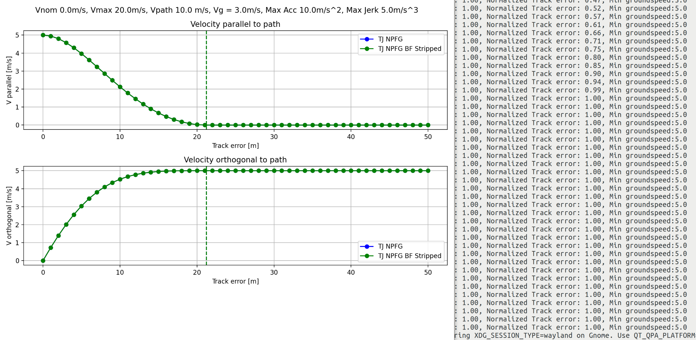
* 2042: BAck from Luzern. I added the commit to fix this (min ground speed user setting override), so will be interesting to develop algorithms further with this basis now!!
* 2149: Wow the laptop charging only till 65% after an hour. That’s weird it’s realy slow!!
* 2304: Read interesting article about jerk-optimal trajectory. Note that this doesn’t respect the *max jerk conditions, but still it’s really interesting. Cuz at the end it also defines the ‘minimal time’ the condition can be feasible, under certain jerk limits
* Also would be interesting to use (a bit of a blackbox tho): <https://github.com/pantor/ruckig>
  + <https://pypi.org/project/ruckig/>
* 2333: Logging so I don’t forget
  + Initial inspiration: “A MINIMUM-JERK TRAJECTORY” from <https://mika-s.github.io/python/control-theory/trajectory-generation/2017/12/06/trajectory-generation-with-a-minimum-jerk-trajectory.html>
  + This gave an intuition that 2D motion jerk-optimal trajectory is linear trajectory (perhaps expected)
  + Then in “Jerk-limited Real-time Trajectory Generation with Arbitrary Target States” paper, that published Ruckig library, more references are found
  + “Path-Accurate Online Trajectory Generation for Jerk-Limited Industrial Robots” gives some sense on path-following (not exactly accurate) for a robot arm application. My problem is basically a *dummed-down version, with more flexibility of the end-effector, so this paper alone could be a massive help
  + Then “Analytical Time-optimal Trajectory Generation and Control for Multirotors” gave more sophisticated insight into Quadrotor control & what kind of trajectories are feasible for quad platform!
    - There’s even ‘snap’ optimized trajectory paper by Kumar cited, but not sure if it’s relevant.
* Overall, just lots of ideas. I’m wondering which one I can pick first. Probably ruckig library.
* 2424: Will sleep, but interesting to think about this, and I think this initial implementation will open the door for future iterations. It’s just a beginning: <https://github.com/Jaeyoung-Lim/windywings-gym/pull/10/commits/c87e6380c5b12920f56b858885f0263aae64ccbd>

### Jan 11, 2023 - Velocity curve tryouts

* 1518: While formulating the Velocity - Position graph, as well as regarding Jerk, <https://docs.px4.io/main/en/config_mc/mc_jerk_limited_type_trajectory.html> seems like a relevant resource that I should be reading.
  + PX4 Christopher: Efficient safe corridor navigation with jerk limited trajectory for quadrotors
* <https://github.com/Auterion/Flight_Control_Prototyping_Scripts>
* TrajMath.hpp and VelocitySmoothing.hpp

### Jan 10, 2023 - VF and Ramp in Curve Visualization

* 1345: At Irchel, wanna get the first goal of the week done today, so I can formulate the new logic tomorrow.
* 1550: Initial VF & velocity curve drawing complete. But quite unintuitive!
* 1705: Back from coffee break & will do stuff for ~40 mins. Maybe LaTeX?
* 1740: Was doing <https://www.overleaf.com/learn/latex/Learn_LaTeX_in_30_minutes>. Pretty fun!
* 2142: Back home, ate ramen and was chillin, insta-grammin 😱. Now wanna do some LaTeX + Velocity curve formulation 🤔
* 2154: Dishes done, LaTex Start!
* 2231: Done! But took like 2hr ish maybe.
* Result: [Simplest_working_example_LaTeX_document_Junwoo.pdf](https://drive.google.com/file/d/1oXmwHlCq2KhYaxuzeUfuXWLxTHGVrhLv/view?usp=sharing) lmao

### Jan 9, 2023 - Monday, presentation day!

* 0950: Will aim to do presentation & have meeting & (oh no today is the weekly meeting!!) learn LaTeX
* 1025: After some (still impacted by the argument and crying of last night) reading of Handling Big Jets & Bamboo zahnbuersten kalender artikel, resuming on presentation prep. Goal: Get it done by **1040**, and leave and arrive at ETH at **11am**.
* 1235: Presentation done! (Btw left house at 1110 or sth, always late haha) And Roland was interested in the solar airplane haha
* 1308: Weekly report sent. Although is feels daunting, let’s get started on Jerk-limit formulation, I need to try to fail, to learn!
* 1419: At SPH, will come up with the graph for jerk

## Week 7 - Jan 2, 2023 ~ Jan 8, 2023

GOALs

1. ~~Week 6 report send~~
2. ~~Intermediate presentation preparation - Jan 12, 2023~~

### Jan 8, 2023 - Getting more serious about VF manipulation …

* While preparing the [8_Intermediate_Presentation](https://docs.google.com/presentation/u/0/d/1gdoeVaushm6uMP61ysq2CldqRS2swrc1veAt2cJ-c5w/edit), I realized I didn’t have much that I actually ‘achieved’. So it is really kicking my ass to come up with a different VF calculation logic 😏
* 1630: At the mall, Geneve.
* 2139: Presentation feedback from Jay, fixing to be more ‘bullet’y 😉

### Jan 6, 2023 - Friday, Intermediate presentation prep and beyond

* 1634: Finalizing Intermediate presentation. Taking inspiration from Max? Of ARIS, more pics and more talking, no letters.

### Jan 5, 2023 - Thursday, full day of focus ahead

TODO

* Buy new NLOG
* ~~Sunrise mobilezone reply~~
* ~~TJ NPFG chat ask~~
* ~~Cancel half rent for this month~~
* Send money from Korean Bank to UBS
* 1124: After watching Chrigel Maurer videos for 1 hr ish, finally getting into the research again!
* 1223: Was researching Summer research opportunities. Seems like probably CERN, EPFL and individual inquiries will be the best options
* 1456: Finally focusing at Hoengg. Let’s go back to the Meeting Notes
* 1543: Cleaned up the code and now the simulation works properly (point-mass model, NPFG).
* 1630: Was working on VF visualization. And Sunrise will get canceled automatically by March 31st, yay!
  + Will prob pay **29 -> 55 (26 extra)** for February & March of 2023, but that’s ok.
    - It is ouchy for 52 CHF extra fee, but considering I’m not even going to pay the 100 CHF fee, I think it’s a good deal. Won’t make it more complicated 😉
* 1643: Initial VF visualization done! Seems weird, something is wrong 🤔
  + 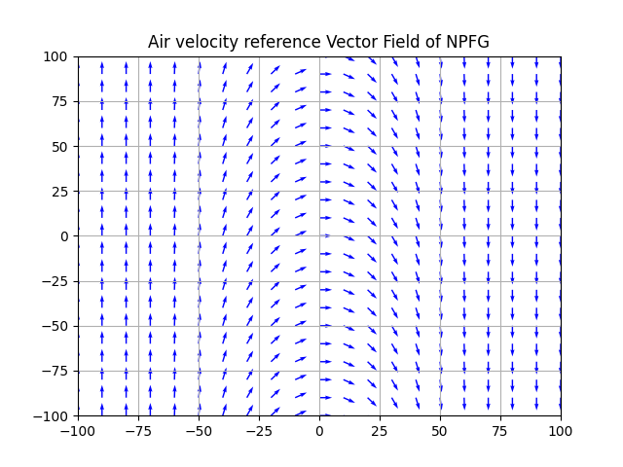
* 2020: Back after dinner at home, let’s get the VF visualization done!
* 2054: Got first report for VF up
  + <https://krajit.github.io/sympy/vectorFields/vectorFields.html>
  + <https://numpy.org/doc/stable/reference/generated/numpy.meshgrid.html>
    - Took some time to understand, but yes, of course for mesh of size M*N, we want each X and Y coordinates in M*N matrix form!
  + <https://matplotlib.org/stable/api/_as_gen/matplotlib.pyplot.quiver.html>
* <https://krajit.github.io/sympy/parametricPlot/parametricPlot.html>
  + Could be useful to generate spiral paths in the future

### Jan 4, 2023 - Wednesday, first meeting after 2+ weeks!

TODO

* Buy new Note (new NLOG!)
* **Apply to** [**Summer 2023 Research Internships**](https://docs.google.com/document/u/0/d/1Jj6r4ZJ5xYN4fwIK204MIsNRqr_YCYO_lSB4VzZpRKw/edit) **before it’s late.**
* ~~0919: Woke up 9am (I guess I do wake up when things are important lol), but need to check on 성평등 세미나 thing first.~~
* 1222: Well slept till 1150 ish again (why? Paris?), and now planning to go to Zentrum to prepare the BA meeting 😨.
* 1245: Was writing literature survey & weekly report (oh so late, haha)
* **1434**: Funny Milk foaming machine mishap at ASL. Michael is taking care of it 🥛. Wonder if it is actually broken 🤔
* 1807: Irchel, PX4 Dev Call and some discussions, just sent SHV email on Insurance. Christopher guy from PX4 is interesting, but just asking tons of questions 🤔
* 2339: Just trying to get this *unrelated wave simulation to work lmfao, gazebo garden?! <https://gazebosim.org/docs/garden/install_ubuntu>
* 2429: Enough for today, at least I got the rubber ducky thing to work. And building the Wave GUI somehow removed other errors? Now the only error left is:
  + 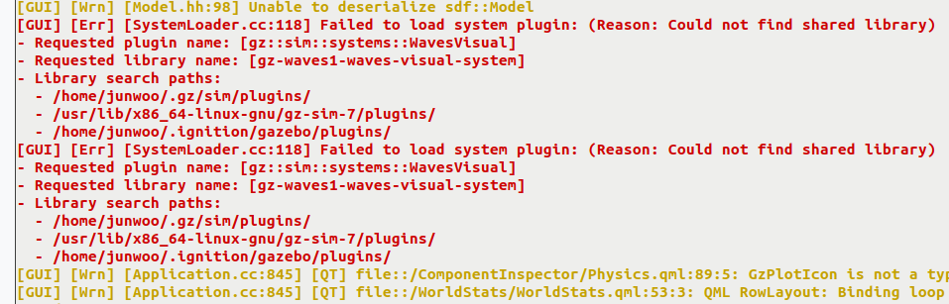
* GN!

### Jan 3, 2023 - Tuesday, first day back after Paris

* TODO
  + ~~Install ROS2 and build the Medusa paper package~~
* Woke up at 11am (sluggish day), and researched about exchange rates, bank transfer, currency strengths, Credit Suisse situations, economy, etc. Super fascinating. Trying to keep myself interested in various sectors. And not feel too bad about doing something *out of the thesis.
* 1808: Now getting back to thesis stuff. Need to get the diagrams ready by tomorrow meeting, and to make progress.
* Not sure if I should really install the ROS2 ‘rolling’, as it has some problems apparently? (Due to Ubuntu 22.04)
* <https://ros.org/reps/rep-2000.html>
* <https://docs.ros.org/en/humble/Installation/Ubuntu-Install-Debians.html> is the latest active one (except Rolling, which was released in 2020 or sth?)
* Ah the bug in apt seems to have been fixed: <https://salsa.debian.org/apt-team/apt/-/merge_requests/248>
  + This bug was fixed in the package apt - 2.5.2
* Nice to learn about PS: <https://www.thegeekstuff.com/2008/09/bash-shell-take-control-of-ps1-ps2-ps3-ps4-and-prompt_command/>
* <https://bashrcgenerator.com/>
* <https://askubuntu.com/questions/466198/how-do-i-change-the-color-for-directories-with-ls-in-the-console>
* <http://www.bigsoft.co.uk/blog/2008/04/11/configuring-ls_colors>

## Week 6 - Dec 26, 2022 ~ Jan 1, 2023

GOALs

1. Draw a velocity setpoint vector-fields in a 2D plane, to visualize NLGL
2. Or, simulate vehicle in different initial states, to showcase monte-carlo stylistic view of simulations
3. Try different velocity-setpoint ramp-in methods in cartesian coordinate frame

<https://github.com/dsor-isr/Paper-PathFollowingSurvey>

<https://github.com/hungrepo/path-following-Matlab>

### Dec 30, 2022 - Friday, Quadrotor paper read in Train

* 2122: Quadrotor PF review paper organized in literature review & remembered about vector field drawing task we discussed during the last meeting!

### Dec 28, 2022 - Wednesday, back in da loop

* PLAN
  + ~~1120 ~ 12:50: Block 1; Different path following algorithms, write down & understand~~
  + ~~13:30 ~ 15:00: Block 2; Multicopter PF formulation research/ existing approaches~~
  + 15:30 ~ 17:00: Block 3; Windywings implementation of path … ahh idk
* 1100: Feels like today is the proper re-start (unless I go fly tmrw?)
* 1432: Had lunch. Oops was researching Revolut and housing insteaddd.

### Dec 26, 2022 - Monday, after bath

* Will watch Avatar later too, so need to be strategic in time management
* 1623: Was Avatar research + paragliding site search / whether I should go back tmrw or sth

## Week 5 - Dec 19, 2022 ~ Dec 25, 2022

### Dec 24, 2022 - Some more research & prepping the weekly report

* 1654: We are soon leaving for Mamis anyways, shall I just send the weekly report as of now? (Mostly just merry-christmas) Not sure.

### Dec 23, 2022 - Wow, Friday and starting for the first week!! 😨

1. 1141: Right, I am ‘supposed to’ be doing the thesis. Let’s make plans and executeee
2. 1247: Starving, but reading: “Overview: A review of path following control strategies for autonomous robotic vehicles: theory, simulations, and experiments”
   1. <https://en.wikipedia.org/wiki/Nonholonomic_system>
3. 1505: Back. Will dive deeper into the overviews.
4. 1516: I think I understood what ‘non-holonomic’ is supposed to mean. Unicycle option helps and the 8 tests (4 from each eq, each on dx and dy components) is quite interesting!

* 2143: Was doing flight review stuff in the medic library. Pretty fun! But also bokeh and html are quite exhausting. Learned a lot, would love to implement some stuff! (And it’s quite dirty haha)

## Week 4 - Dec 12, 2022 ~ Dec 18, 2022

Weekly Goal

* ~~Week 3 Report~~
* Finally a VLOG out?
* NPFG Understanding & Complete implementation in Sim environment

### Dec 15, 2022 - Thursday, Environment re-write day!

* 1038: Just finished dressing the paramotor. The skid surprisingly fits great! Really satisfied with the design. Not having a ‘planer’ surface is the only thing that’s irritating, but everything else seems fine.
* 1138: Second print is on! And no rush for getting pixhawk ready today, phew! Nice to know, so I will do CG-balanced flight today, *maybe with GoPro. Step by step!
* PLAN
  + **~~11:40 ~ 13:10: Focus Block 1. Environment overhaul~~**
  + ~~13:20 ~ 14:00: Lunch~~
  + **~~14:10 ~ 15:10: Hoengg, second testing of paramotor!~~**
  + **~~15:00~ 16:30: Focus Block 2, NPFG Velocity setpoint based navigation MC implement~~**
  + **~~16:40 ~ 17:30: Focus Block 3.~~**
  + 17:00 ~ 18:00: Move to ML building Zentrum, and join ARIS
* 11:44: Overhaul start!
* 13:02: Point-mass Multicopter environment done!
* 14:56: Das wetter ist nicht sehen an. At SPH Hoengg, will stay here till 5:30pm max I think, 2.5hr!
* 17:16: Was quite focused. Improved a lot on environment and all. I think it’s much better! Point-mass MC model NPFG control with air-velocity reference works! Now going to Zentrum…

### Dec 14, 2022 - Wednesday, meeting day!

* PLAN
  + ~~9:00 ~ 10:30: Focus Block 1~~
  + ~~10:40 ~ 12:!0: Focus Block 2~~
  + **13:30 ~ 14:45: Focus Block 1**
  + 15:00 ~ 16:00: Weekly Meeting #4 at ASL
* TODO
  + ~~Get LiPo Battery~~ **~~charger~~**
  + Design & Construct **skid**/platform for Paramotor
  + Get **Pixhawk** working on the paramotor w/ (or wo/ GPS)
  + Get **Receiver** to work
  + **KU Google Drive Files Purge**
* 2am: Having fun with this MC NPFG *kinda working. It’s quite interesting to watch how the ground velocity changes. I wonder what is causing this, it *has to be the acceleration cap, since the acc should be always orthogonal to ground velocity, thus magnitude of velocity shall never change.
  + But the accel cap is in the end changing the direction of accel (which we don’t want!), and it results in weird trajectories
  + 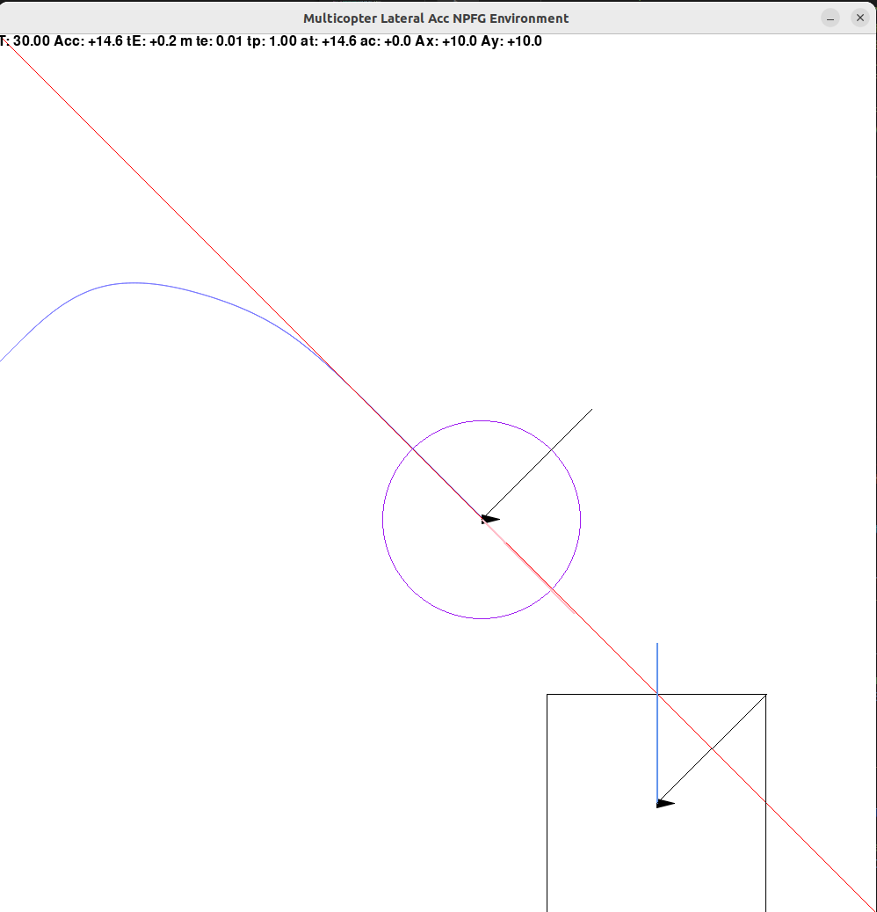
* 08:38: Reading GNC on Paramotor paper for refreshment & fresh ideas!
* 10:45: Oops, I was having too much fun with Paramotor research. Let’s go to ETH now!
* 13:30: At SPH, now I have ~1 hour and 15 minutes to focus. Let’s go!
* 14:47: Ok I think I’m *kind of ready?
* 16:41: Finished meeting, oof it was hard to get through, but I feel like I am learning marginally every time, and it’s always nice to have more feedback!
* 17:34: Well Dev-call ended super quick! Let’s design **chassy** for the Paramotor nowww!

### Dec 13, 2022 - Wow, Tuesday, early start but just paramotor-ing

* 17:30 Shocking that I am now writing a note for today for the first time. Definitely didn’t spend much time with my thesis!! 🤦
* This is how I spent time:
  + 6am ~ 8:30am: Tidying stuff, Bill management, Chilling (No phone!)
  + 8:30am ~ 9:30am: Chilling with Laura & Laundry tryout
  + **10am ~ 11:30am: Going back and forth, buying drill-bit, charging Battery (Neto), and surprisingly meeting Christian! Worked 20 min in the bus 80, dizzy!**
  + 11:45am ~ 12:45am: Lunch and Coffee with Alper, ‘deCypher’ project
  + 1pm ~ 3pm: Trying and troubleshooting with Paramotor, and little photoshoot at SPH
    - This was painful haha, with resistors and all!
  + **3:10pm ~ 4:20pm: Flying Paramotor at the hill**
  + 4:30pm ~ 5:10pm: Getting warm & doing BOA dial warranty request, cuz left one is sorta broken 👅
* PLAN
  + **~~17:40 ~ 19:10: Focus Block 1, NPFG Multicopter re-formulation to remove ‘unicycle’ control method~~**
  + 19:20 ~ 20:00: Dinner and home?
  + **~~20:30 ~ 22:00: Focus Block 2, NPFG quantification / diagram export for tomorrow discussion~~**
  + **22:20 ~ 23:00: Prep meeting notes for tomorrow.**
* 17:41 Start now!
* 18:40: Had a nice discussion with Terrence, and Naim! Nice to attend ARIS event on Thursday
  + Parafoil project reminder: <https://aris-space.ch/periphas-2022/>
    - IDSC collaboration?
  + Chris, ex-fokus projekt member is proposing the TVC: <https://aris-space.ch/team-2021-22/#astrea>
  + Ah there was also a previous project: <https://aris-space.ch/phoenix-2021/>
* 19:01: Oops was quite side-tracked 😓. I can still focus for 20 mins! Or, shall I go for dinner with laura?
* 21:19: At home. Wow, only 2 hours passed? Anyways, need to now prepare for tomorrow’s meeting & discussion points.
* 22:49: Uh oh, I was too focused on paramotor research and controls.. Need to wrap up simulation/formulation tonight!!
* 23:52: Back on it. Will construct the meeting note as first agenda.

### Dec 12, 2022 - Monday, fresh morning

* 10:54: Ok NPFG had some nice improvements (Debug output, actual path following, screen scaling, etc). Now finishing up the Weekly Report.
* 11:13: Report sent! NIce to have this routine every week 👍
* 12:56: Back from lunch. Also said hi to josh again 👐. Now the Simulation debugging continues.
* GOAL
  + **~~1pm ~ 2:30pm: Focus Block 1: Draw out what’s happening inside NPFG~~**
  + **~~2:40pm ~ 4:10pm: Focus Block 2: NPFG troubleshoot & multicopter tryout?~~**
  + **~~4:20pm ~ 5:50pm: Focus Block 3: NPFG Evaluation metric formulation~~**
  + 6:30pm ~ 6:50pm: Ramon Call prep
  + 7:00pm ~ 7:30pm: Ramon Call
* 14:11: Closest point on path visualization working! Exciting to peak- into the logic’s internals. It’s not as hard as I thought!
  + 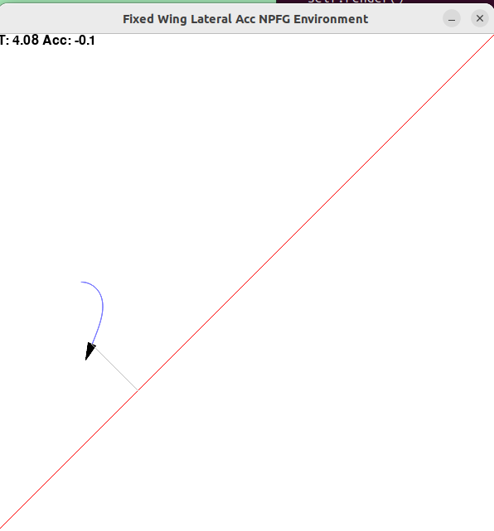
* 14:40: Oh, I missed the break timing. Will get some rest 😆
* 14:47: Back with tea! Becuz the hot chocolate thing is broken lol, rattling noises!
* Ah I can tell that it’s excessive acceleration, by 1 second window method
  + 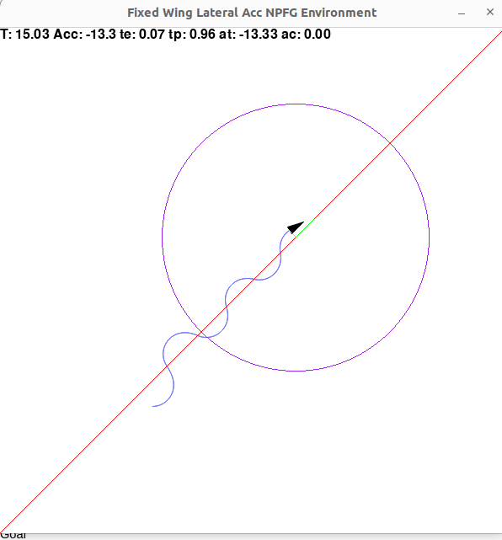
* Lol found out why it was oscillating. Bug in the NPFG where I rotated by (PI - Look ahead angle), instead of (PI/2 - look ahead angle), resulting in PI/2 extra excessive bearing setpoint lmao
* 17:17: Trying to solve the MC NPFG application mystery. Not so easy! I need some visualizations to debug this.
* What kidn of ‘metric’ would make sense for NPFG?
* 17:48: Writing equations, to prevent getting into a rabbit hole, as TJ said haha

## Week 3 - Dec 5, 2022 ~ Dec 11, 2022

Weekly Goal

* ~~Implement NPFG in Windy Wings Environment~~
* Test Multicopter / Fixed-wing with NPFG logic
* **Hobby VTOL** design complete & parts order

### Dec 11, 2022 - Sunday morning & night coding

* Basically implemented NPFG in the morning & evening
* Being focused really helps! Also read about ‘micro-writing’ technique. I can write my thesis one step at a time 🙏

### Dec 10, 2022 - Saturday chill

* Lots of s and nothing much 😆

### Dec 9, 2022 - ASL Open Lab day and re-thinking

* 18:51: In Train to Auterion Christmas Event. Few important points
  + Making the library pretty and all doesn’t contribute towards simulation/result.
  + I should focus on making the idea work, instead of trying to architecture in a *good (my definition) way.
  + Good engineer knows when to be practical, and when to be anal. Be flexible!
* TODOs
  + Implement NPFG in any way tonight.

### Dec 7, 2022 - Wednesday, Ubuntu env is set up!

* 00:37: Finally writing this with my dual boot ubuntu setup. Hihi, so happy that I have a proper Ubuntu running now! Excited about its possibilities. The Windywings is working flawlessly now, super cool!
* To Read:
  + <https://www.hamvocke.com/blog/a-quick-and-easy-guide-to-tmux/>
* 09:22: At Irchel. Just emailed Christian regarding the autonomous sailing boat. What a cool project!
* PLAN for the day
  + **~~09:30 ~ 11:00: Focus Block 1, implement NPFG part 1~~**
  + **~~11:10 ~ 11:50: Micro Block 1, move to another building, read some papers?~~**
  + ~~12:00 ~ 13:00: Bouldering at Irchel~~
  + ~~13:30 ~ 14:00: Mensa Lunch~~
  + **~~14:30 ~ 16:00: Focus Block 2, NPFG part 2~~**
  + **~~16:10 ~ 17:00: Micro Block 2, NPFG part 3~~**
  + ~~17:00 ~ 18:00: PX4 Dev Call~~
  + 19:00 ~ 20:00: Skydio Dock Day tune-in
  + **2015 ~ 2215: Shu dinner at Oerlikon**
  + Chill?
* Learning Gym environment.
  + Wow the `make` function is just pure overloading of each environment available. Interesting! Do they update this manually? Also, how does ‘custom environment’ package registration work?
    - 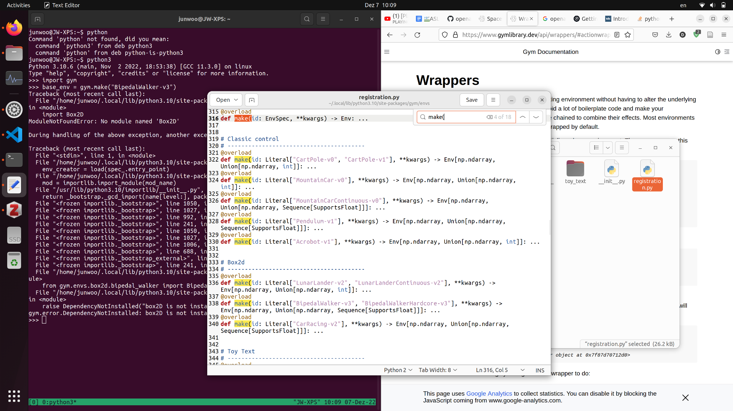
    - Wtf it somehow got installed with errors?
      * 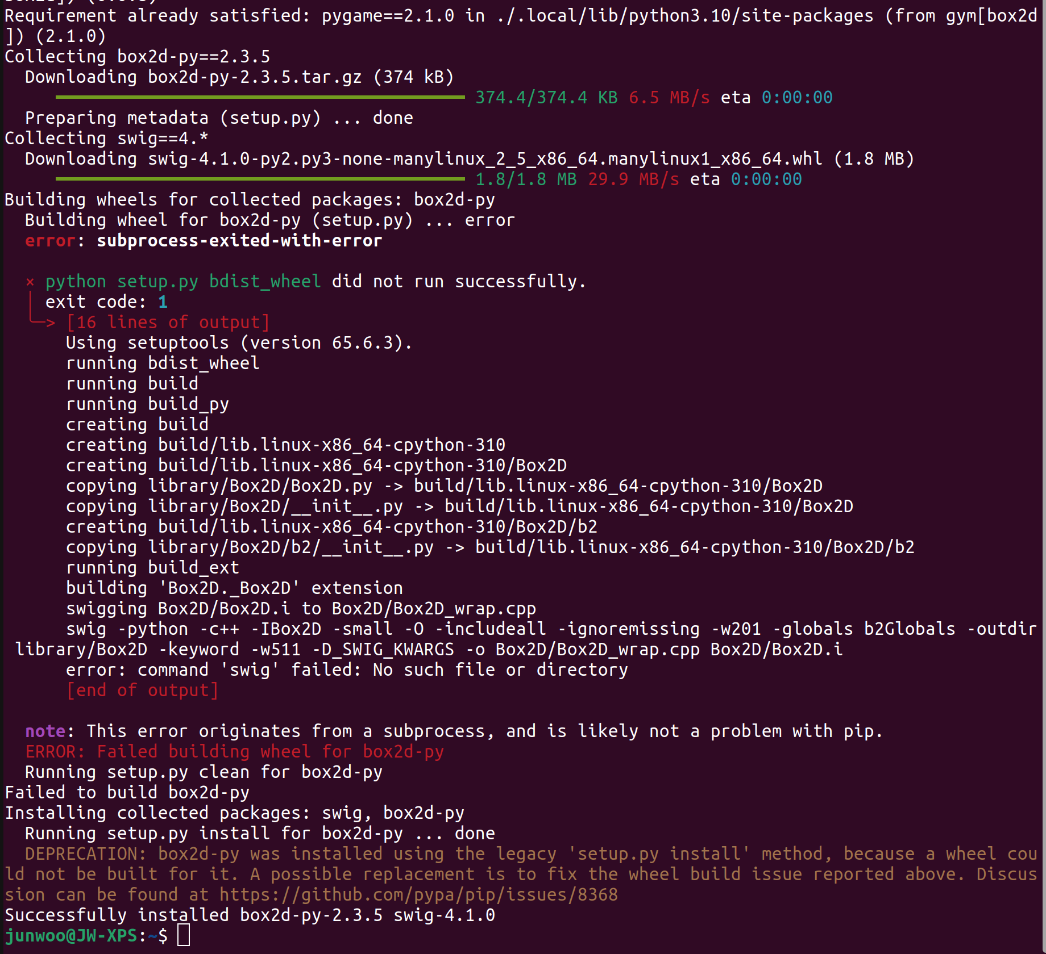
    - <https://www.gymlibrary.dev/api/wrappers/#actionwrapper>
    - <https://blog.paperspace.com/getting-started-with-openai-gym/>
  + <https://www.gymlibrary.dev/api/spaces/#dict>
* 11:34: Ok, the path forward for implementing NPFG is clearer. Env is better set up & got some feeling through some examples online: <https://gitlab.com/leocus/ge_q_dts/-/blob/master/dt/decision_tree.py>
* 14:45: Starting research again. At the Irchel building, it’s quite full with people! Nice talking with Robin, Political Science Bachelors student from Rapperswil.
* 17:53: Dev call was so messy. Hmm quite sad that it’s not organized/professional.
* 18:46: Losing focus. Will go home now, also it’s quite dark. Need to figure out this Gym `render` function tho!!! How should it actually be used? Any good examples?

### Dec 6, 2022 - Tuesday, WindyWings Formulation Day

* 10:44am: At ClausisBar place (Not LEE), nice that there’s an electrical plug! Had a hassle this morning with the sleep analysis of the laptop. Sth weird is going on, but I am hoping this downgrade of Windows will solve this.
* Planning
  + ~~10:50 ~ 11:20: Short WindyWings Env Setup~~
  + ~~11:20 ~ 12:00: Lunch at Polyterasse~~
  + ~~12:10 ~ 13:40: Focus Block 1. NPFG Implementation 1~~
  + 13:50 ~ 15:20: Focus Block 2. NPFG Implementation 2
  + 15:30 ~ 17:00: Focus Block 3. NPFG Implementation & Testing
  + **5:30 ~ 7:30pm: Student Meets Lab (IIET / AMIV) Event**
  + 8:00 ~ 9:00pm?: Enneagram Lectur, Paraworld
  + *Would be nice to construct the LED strip / Christmas set from SPH!
* Module import errors & need pygame??
  + 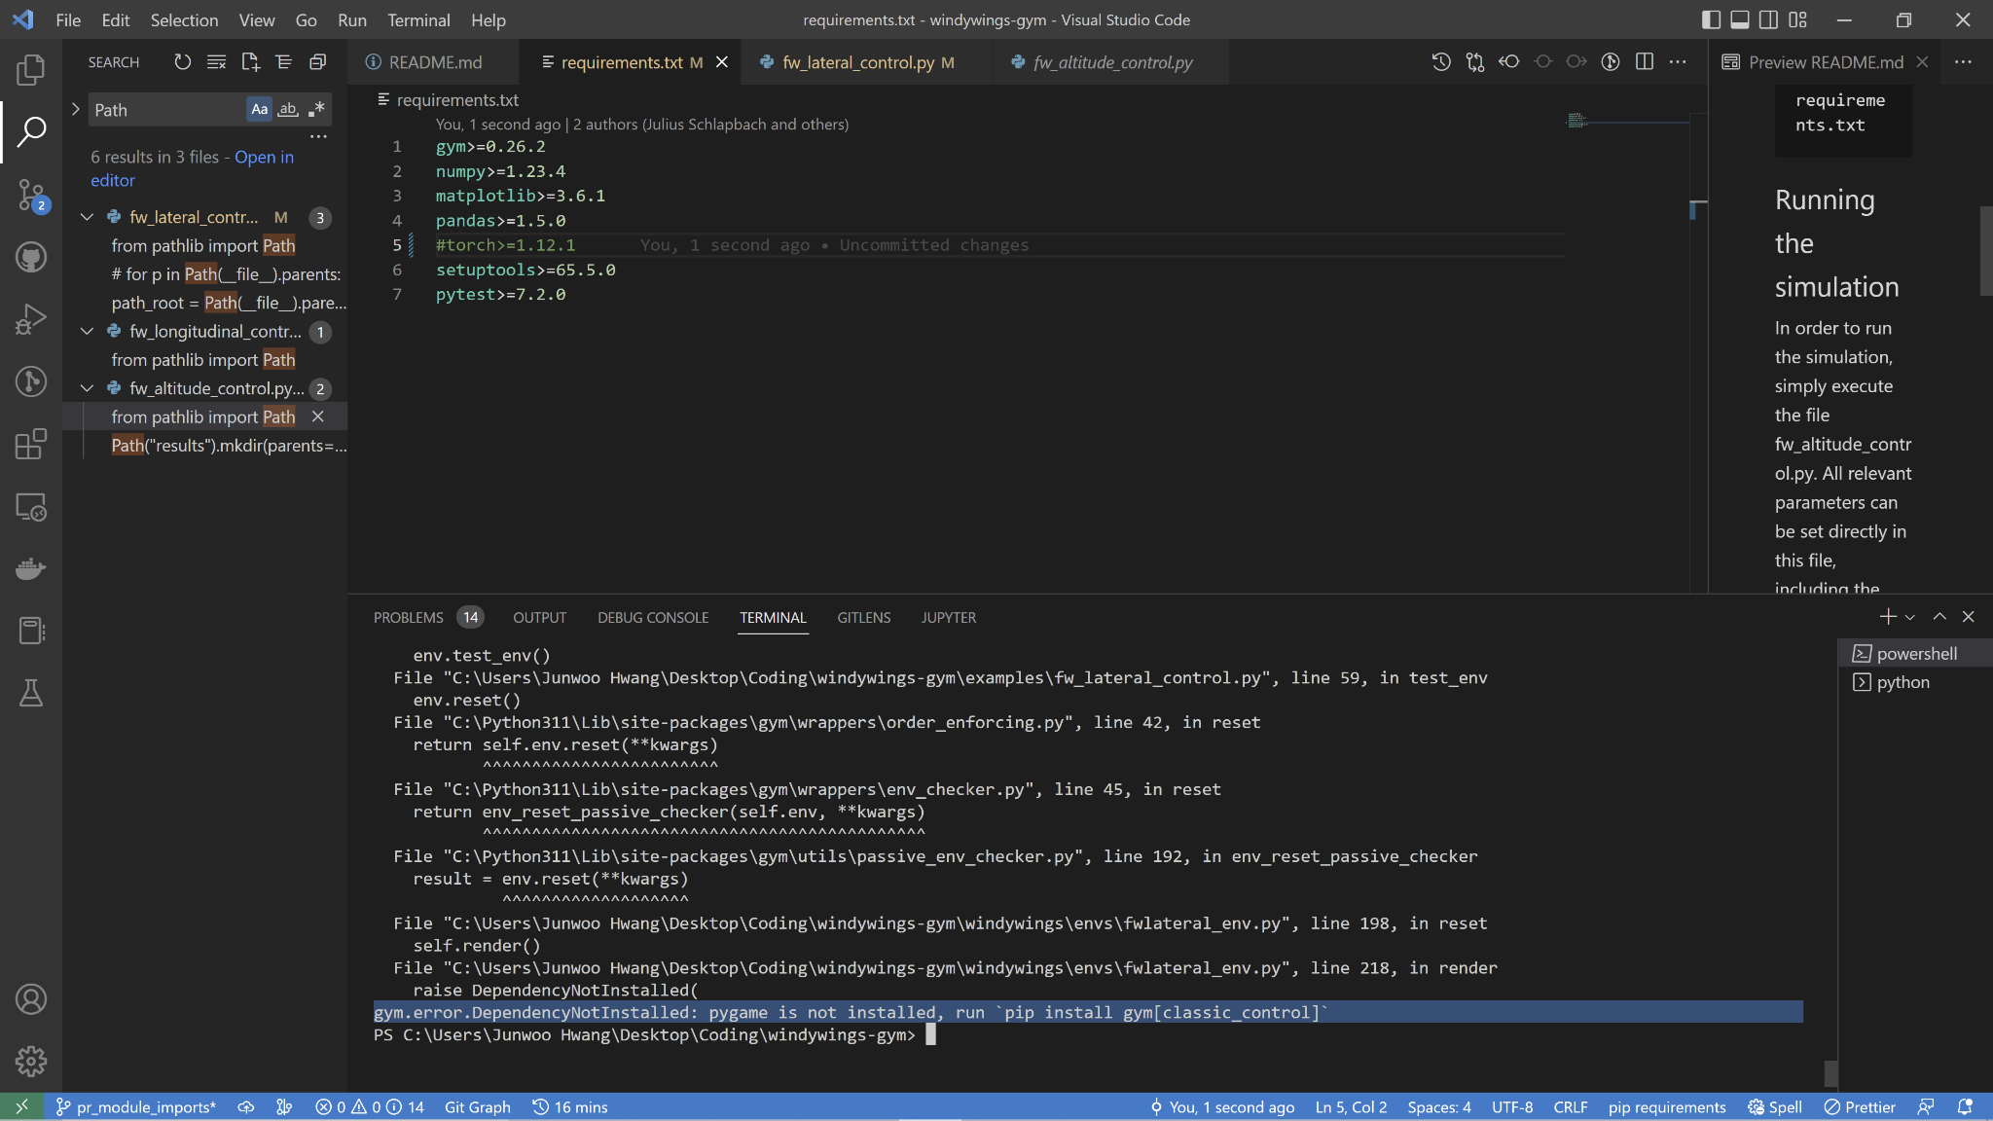
  + Pygame
    - <https://github.com/openai/gym/issues/2691>
    - <https://github.com/openai/gym/pull/2712/files>
    - `pip install gym[classic_control] –user`
    - Oh and windows dependency sucks haha, permission issues
    - <https://stackoverflow.com/questions/2817869/error-unable-to-find-vcvarsall-bat>
    - <https://wiki.python.org/moin/WindowsCompilers>
    - <https://devblogs.microsoft.com/python/unable-to-find-vcvarsall-bat/>
  + 12:21: At SPH Zentrum (with Christmas Star)!
  + Installing compiler: <https://www.pygame.org/wiki/CompileWindows> > MSVC v140 - VS 2015 C++ build tools (v14.00)
  + Ok compile somehow happens (I had 2019 compiler before tho, hmm), but now dependency in header fails: <https://github.com/cython/cython/pull/4428/files>
  + <https://github.com/pygame/pygame/issues/3522>
  + 13:32: Removing files from KU Google Drive. But prob better done tonight. Will just try to log into the new account first then.
  + 13:59: Took a hot chocolate. Hope to get out the NPFG into the WindyWings, with the package built.
  + 14:54: Simulation finally works! In Windows 😋. Dependencies takes a lot of effort!

### Dec 5, 2022 - Monday! NPFG Diagram Day!

* 10:35am: At Zweistein (lol), forgot earphones damn it! Will try to save battery power and understand NPFG properly during the next 2 hours. Also, will plan out the day a bit
* Planning
  + ~~10:40 ~ 12:00 : Focus 1, NPFG understand & basic diagram complete~~
  + ~~12:00 ~ 12:30 : Lunch & Podcast micro edits based on David feedback~~
  + ~~12:40 ~ 14:00 : Focus 2, NPFG Diagram complete & evaluate on multicopters~~
  + ~~14:10 ~ 14:45 : Meeting prep & micro-focus: Gather agendas & questions & additional literature surveys~~
  + 15:00 ~ 16:00 : Weekly Meeting
  + 16:10 ~ 16:40 : AMIV Visit, CAB Building
  + 17:00 ~ 18:00 : [Sprachtreff A1+](https://ethz.zoom.us/j/63327344744?pwd=MExmQ1BGU0tWdzQ2dTQvQjB2MzV1Zz09)
* 1pm: Eating lunch at SPH now actually. Reading NPFG code.
* 2pm: Ah still learning the lower / upper period bounds. Damn it I can’t make it on time!

## Week 2 - Nov 28, 2022 ~ Dec 4, 2022

### Dec 2, 2022 - Friday, finally back on track!

* 1pm: At SPH Hoengg. The vibe is different (less crowded? Or is it just time?), and the mouse tracking is quite bad (keyboard is a bit old too). But, won’t complain!
* 2:40pm: Met Matteo (he was 3D-printing motor shaft)! And now writing a bearing feasibility unit tests, trying to quantify and understand what’s actually going on!
* 3pm: Sent the question to TJ in the Docs, and programming continues!
* 3:20pm: Oh I actually hit the numerical stability issue region!!
  + 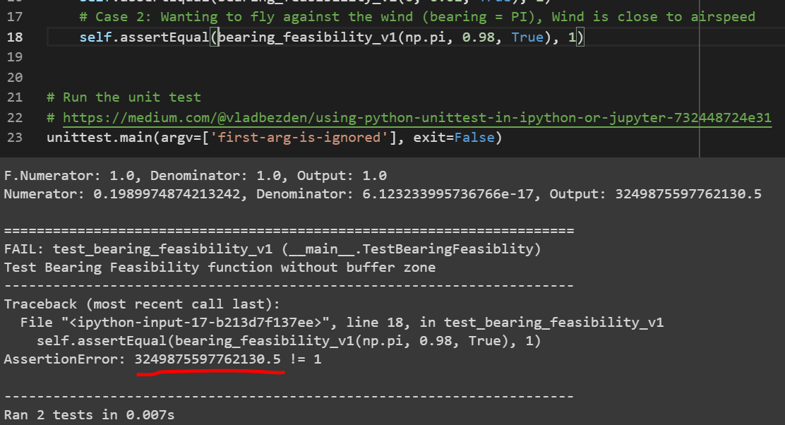
  + 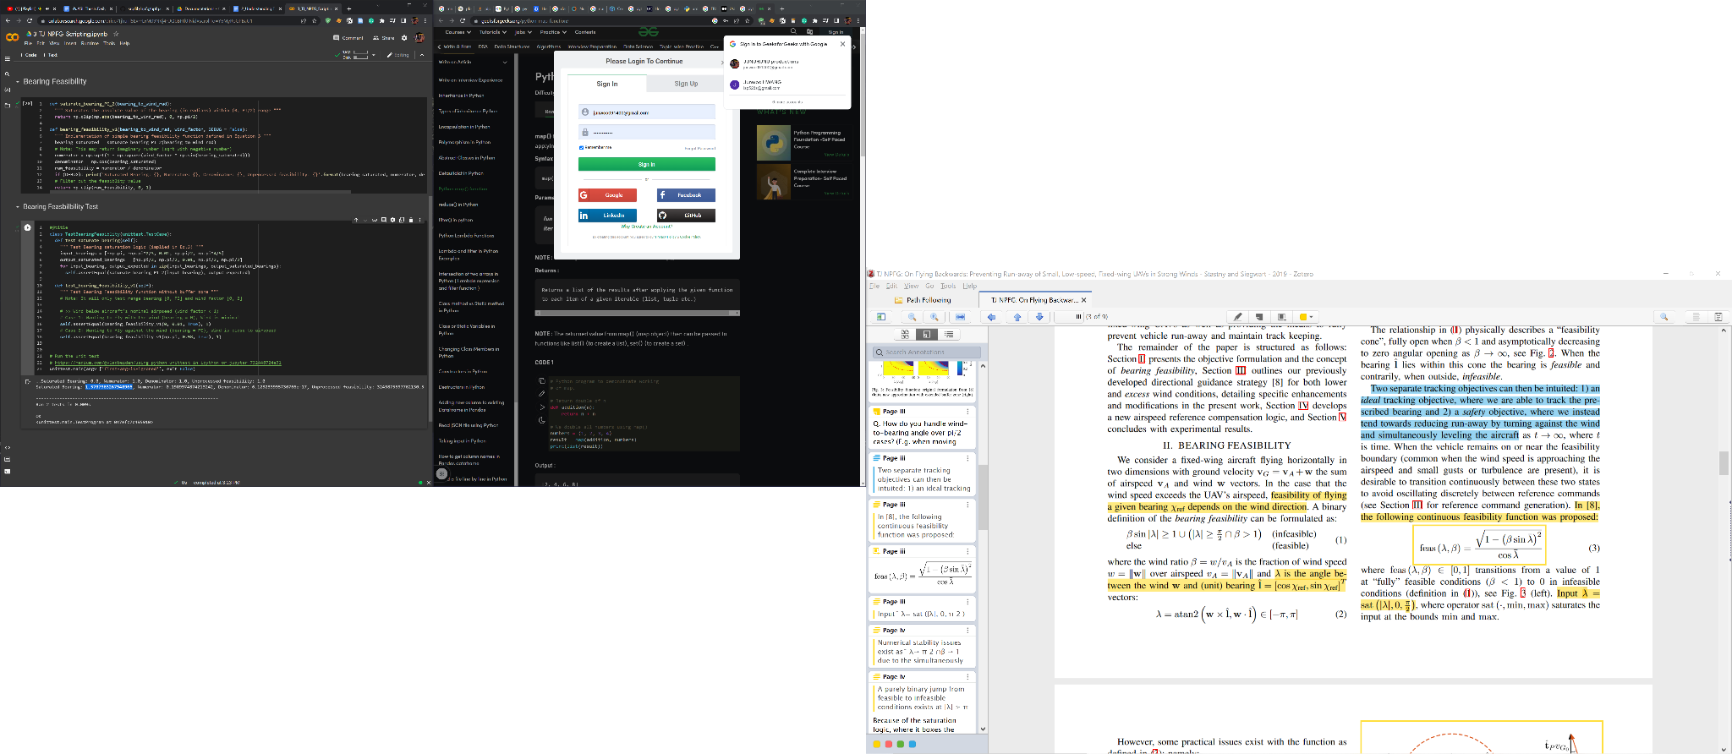
* 4pm: Learned that NPFG Wind factor barrier calculation has been changed as adapted in PX4. But at least I learned unit test formulation & could actually trigger edge cases though! It was fun 🙂
* 5pm: Met a cool guy (Naim Nahas), from ARIS management team. Super cool that they have a different teams and potential Bachelor Thesis student wanting to do control with Cold Gas Thrusters (next Monday)! Although EPFL Rocket Team and them my have a fun competition, I think it’s quite cool to just talk about it freely! Would be super cool to visit Duebendorf office next week-ish, if time allows
* 5:46pm: Infeasible Bearing section entered. Hmm the curvature compensation is now coming fresh in my mind. Also noticing that the logic is only accounting for 2D navigation, so it’s not a 3D NPFG!
* 8pm: Leaving SPH now

### Nov 29, 2022 - Tuesday, mixed feelings

* GOALs
  + **TJ NPFG** Paper comprehend (2hr)
  + TJ NPFG Diagram Complete (1hr)
  + TJ NPFG Simulation in 2D (2hr)

### Nov 28, 2022 - Second Meeting

* Had a second meeting. Embarrassing! (L1 path following != L1 adaptive attitude control 🤦)
* After returning from Norway around noon and having a lunch, it was already 2pm.
* So I barely had time to prepare for the meeting (the weekly report & meeting notes & paper review), and had to crash in & I did learn quite a bit but still realized I am not up to date on a lot of the concepts
* I was really just ‘skimming through’ the papers, reading only what I was interested in. Instead of actually implementing/trying it out/getting my hands dirty. Reading papers only help so much.
* I would need to really devote more time into the project, if I want to get on top of the subject and have more productive meetings. For now, I feel like nothing much was done last week.
* Possibly due to being focused on E3 application (which I still am 😂)
* Had a nice reading session (roughly 4:20pm ~ 6pm) on “**Flying Backwards**” paper. The “Gone with the wind” is a bit poor with graphics, and it is a basis to this one. Pretty interesting relationship.
* I wanna now finish up the research statement (projected to take 5hr 😆), maybe I can do that during dinner at Mensa.

## Week 1: Nov 21, 2022 ~ Nov 27, 2022

TODOs

* ~~Read L2+ paper~~
* Try out NPFG on Multicopter (again, trying out is the only way to figuring out what is possible, in research)
* Email daily about trivial questions, and get feedback (getting stuck on myself is the worst thing that can happen!)
* ~~Ask TJ for Recommendation for EPFL Summer program~~
* Write down **work schedule**, and turn it in to supervisor within Week 2, as described in: <https://github.com/ethz-asl/asl-student-templates/wiki#organisation>

### Nov 25, 2022 - Fifth day, and going to Norway!

* Was mostly preparing EPFL Research statement during the flight. Still working on it (Saturday 00:24 am, as I was watching TV when I got back! 🤦)

### Nov 24, 2022 - Fourth day, getting used to ETH Vibes!

* Woke up around 8am, knew I was too late for Advanced MPC Class, but anyways we packed for Norway, so that was nice ⭐
* Came to AMPC class at 9:40am ish, so was almost close to finishing, but realized they use ‘moodle’ for lecture materials, etc. I am wondering if I want to request access :/
* Goal for today is to come up with some kind of a **simulation** to test the behavior of NPFG/L1/L2+ on a VTOl/Fixed-Wing/Quadrotor, if possible
* Using Jay’s windywings gym. Hopefully I won’t have to install Torch ahah: <https://github.com/Jaeyoung-Lim/windywings-gym/commits/pr-fw-lateral>
* Trying to figure out how to cleanly install Python 3.11 🙂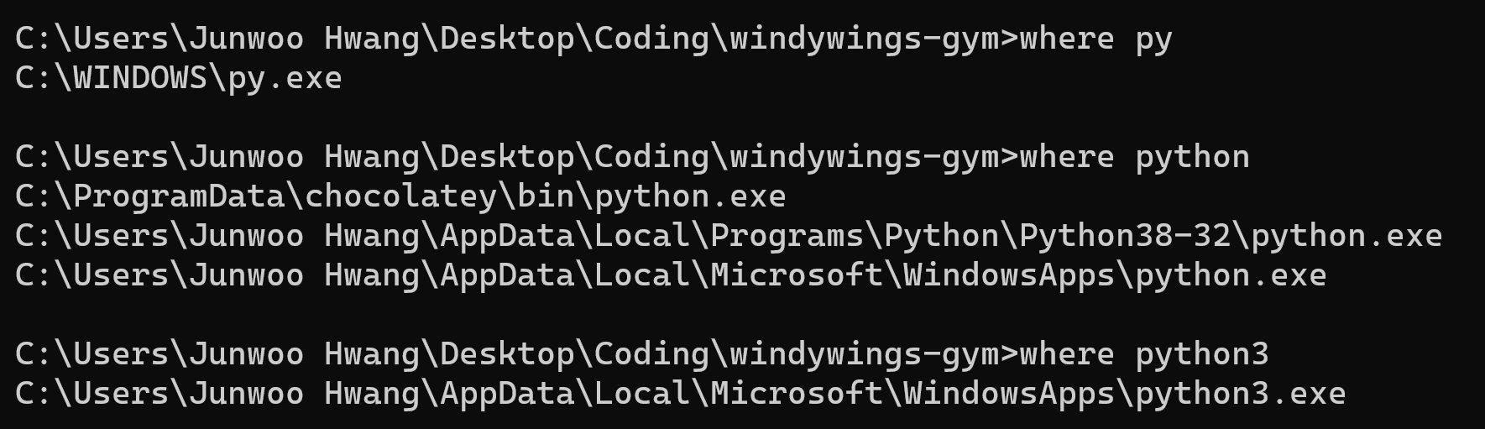
* I had to use `pip3 install` command, what’s the difference 🤯 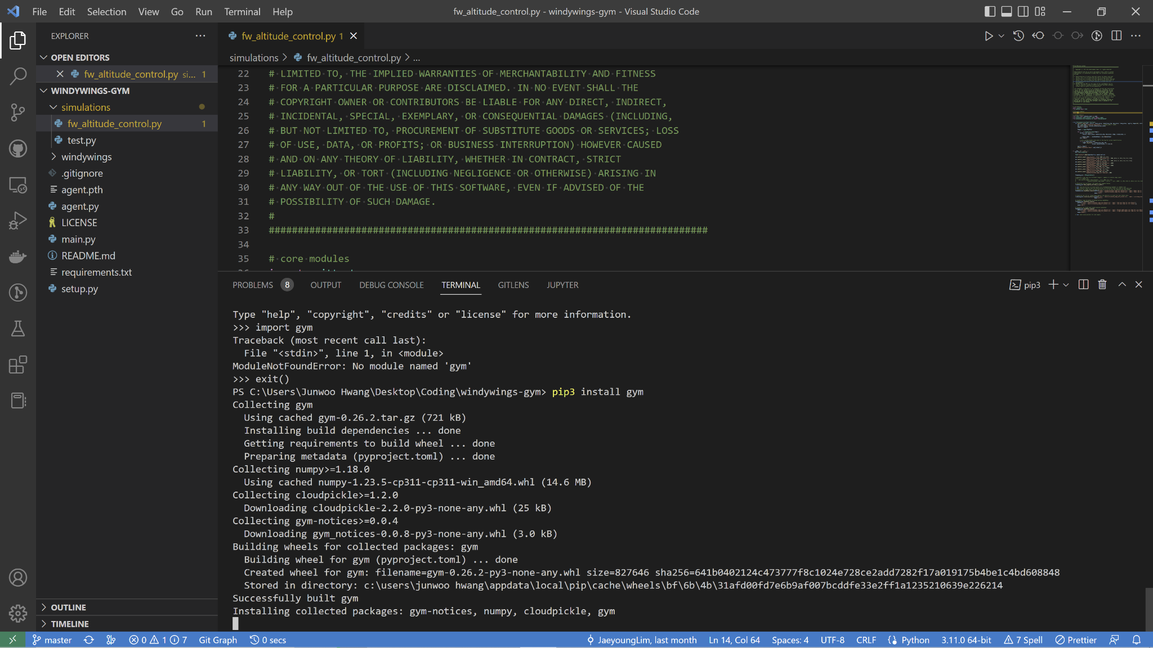
* TJ Said yes! I will continue on preparation for the EPFL EEE program
* Booked a Laser Cutter class in Hoengg, in preparation for fomy plane creations 😋
* 3:22pm: Checked all the EPFL labs that’s participating in E3, but got side-tracked by PX4 and boat, autonomous sailing, etc. Even though it’s cool. I shouldn’t just be researching about them, with my thesis work on hold. But anyways, now need to Hoengg!

### Nov 23, 2022 - Third day, Wednesday!

* Sent email to everyone for a lunch organization (in 2 weeks max), hope they like the idea!
* Also, I will get the VSETH Ersti-Bag hihi!
* I will shower, go to SPH and start Path following simulations / L2+ paper read & doing some actual scripts and researches. To find my own question ⭐
* Met Felix and friends at Polyterasse Mensa, pretty cool to be surrounded by tight group of friends and Austrian / Germany - German! But still, it was quite fast for me.
* Am snaeking in this Masters Thesis room (quite shitty, to be honest). Next to the E 87 - 88 of CAB building.
* 3:36pm : DP and Optimal Control course finished (early). Wow lots of interesting concepts 🤔
* 4:37pm : David being busy to not have time for beer prompted me to think about what I am doing now. Should I really be spending time leisure-ly like this?
* Anyways, in Control Systems 1 course.
* Just found out that my original Zotero had quota of 300 MB (Still very good)! And now added ETH Account, and has Unlimited Quota 😏 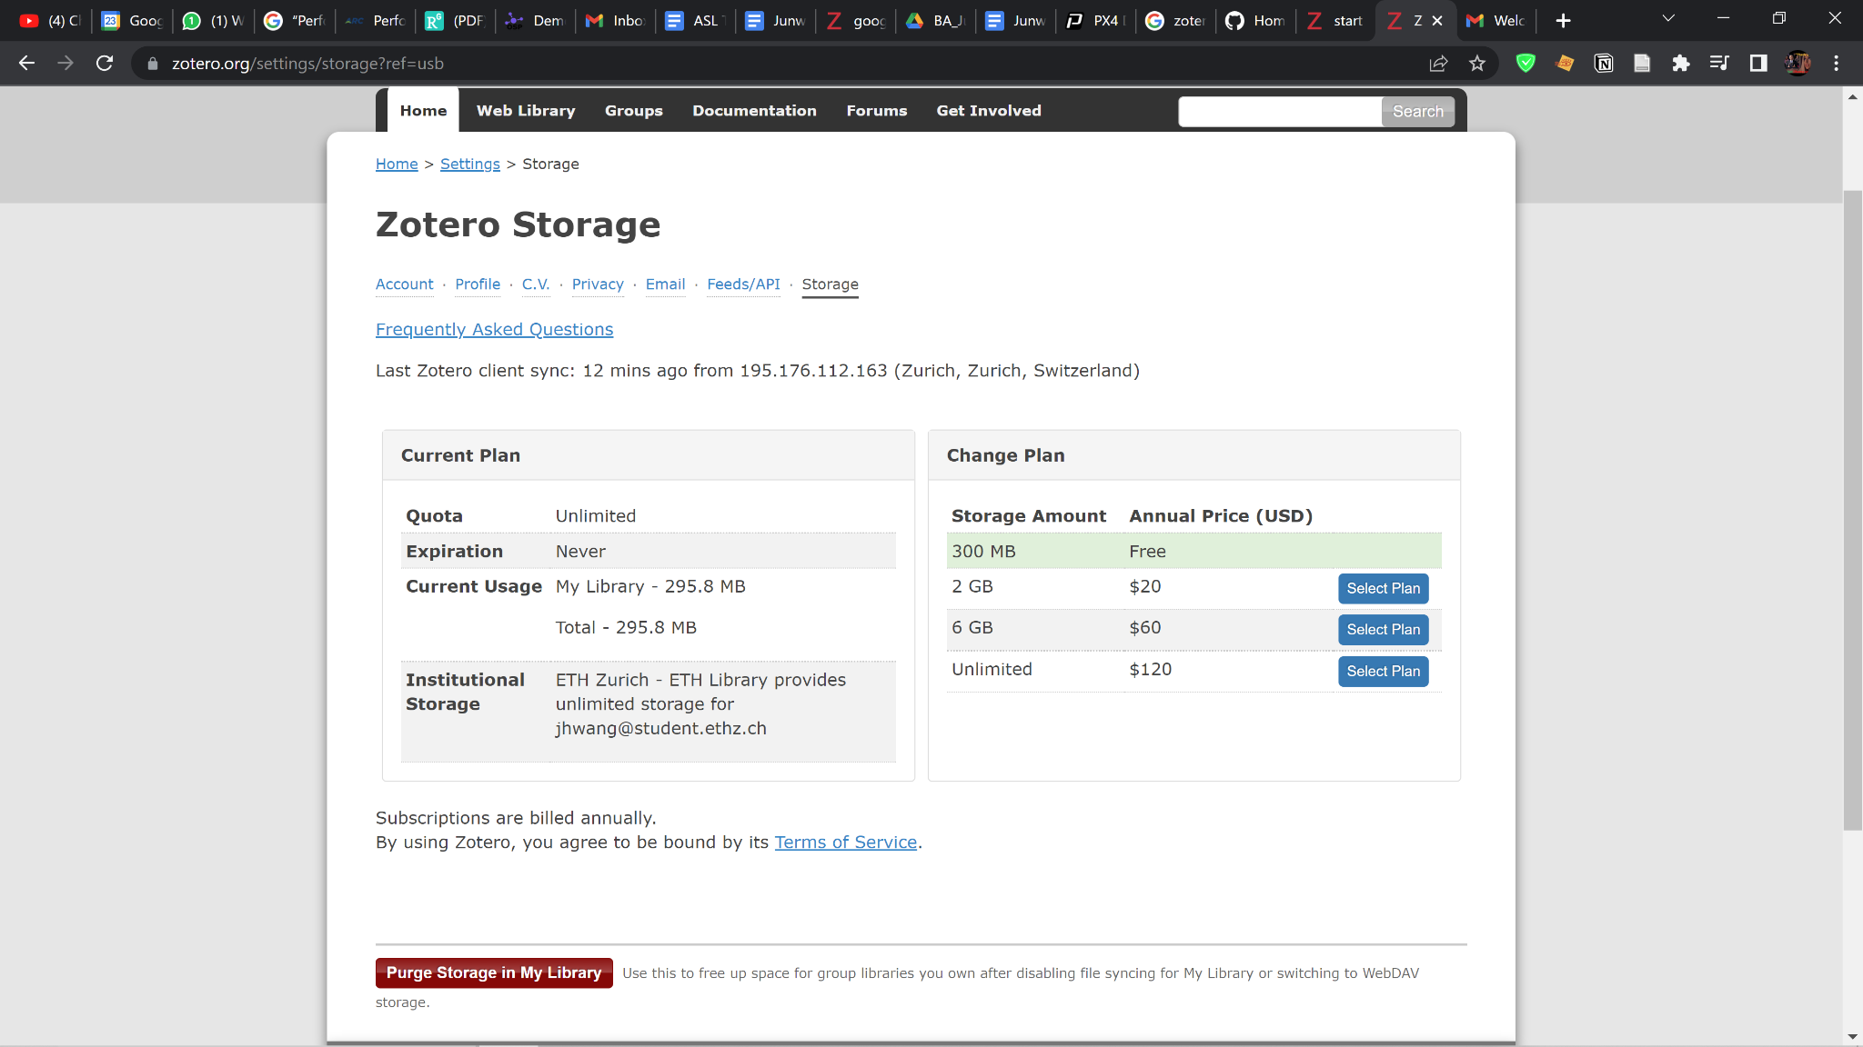
* Had a dev call at ML building, then had dinner at Mensa Polyterasse
* 8:05pm: Now reading again. It’s nice that I am excited to do this, even at night. Like it’s really interesting. Trying to understand L2+ better.

### Nov 22, 2022 - Second day

* Researched about **AMIV**, and sent email asking for membership. Will attend their open day in December
* Went out of the house at around 11:30am or so, I should get out earlier
* Met half-brazilian / half-swiss **Jau** (portuguese name) during lunch
  + Bachelors in Electrical Engineering at 4th year. From Zurich.
  + He wants to do bouldering together! We should do some Irchel bouldering 😀
  + Got to learn that Events are usually what AMIV does.
* Noticed that after working on podcast stuff (cal.com migration & asking for potential guests) that I don’t have enough time to read a lot of papers (now it’s 3:50 pm)
* Will have Deutsch Tandem event at 6pm, at Hoengg. Will try the e-link.
* Today didn’t got to ASL at all. I kind of miss that place, but also for now I don’t need togo
* Met Jeremia at ETH, he ordered PCBs from JLCPCB and will be getting samples in 2 weeks! Sounds fun. Shouldn’t I also do that? (I can do ~ 6 different sample iterations?)
* Should I start building VTOLs now, just for fun? : YES. OR no. ?
* Went to Tandem event of SprachLernenZentrum! Was super fun
* Noticed my SWITCH Edu ID has merge conflict 😏, fixing it!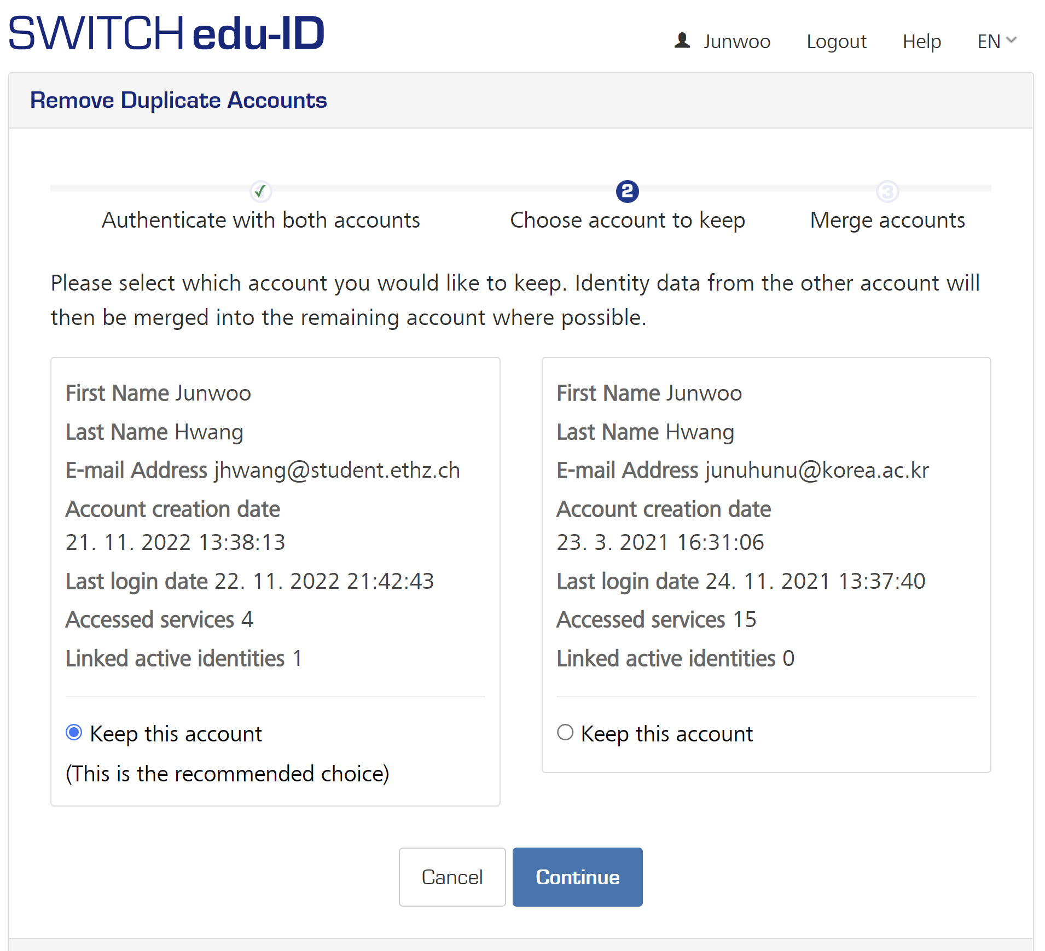
* 9:45pm : Now will have some time to read papers. But it’s super nice that I am calm & relaxed to do so, not pushed to sleep too soon.
* But I do want to wake up around **7am**, as I usually aim for.
* Feels like time is giong slower & I am trying a lot of new things. Now I will ask **VSETH** for the bag 👍

### Nov 21, 2022 - First kickoff

* Collected ETH Student Card
* Contacted Sprachzentrum on Deutschtreff events
* Met Matteo (london born, Zurich native), Mischa (Zurich, doesn’t like Elon) and Florian (Zurich) during lunch
  + All Bachelors in Computer Science 2nd year (I presume)
* Had a kick-off meeting, got to know about David (need to know more though!)
* Had initial very broad conversation on what we need to ‘do’, and the task is to define what I need to do 🤣
* Realized I need to read a lot of papers now haha